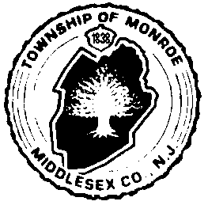
MONROE TOWNSHIP
VOLUNTEER APPLICATION
FOR APPOINTMENT TO BOARDS AND COMMISSIONS

Name:

Address:

Phone: Cell:

Email: (optional)

I would like to be considered for appointment to the following Township Board and/or Commissions
as an unpaid volunteer member:

ADA Open Space & Farmland Preservation Comm.
Affordable Housing Planning Board
Aging, Commission on Recreation Advisory Board
Cultural Arts Shade Tree Commission
Environmental Commission Sustainable Jersey – Green Team
Historic Preservation Commission Zoning Board of Adjustment
Human Relations Commission OTHER:
Library Board of Trustees

Please list any education, prior volunteer experience, work related experience, or other civic
involvement which could be of use to the board or commission, etc. in which you are applying for:

Signature

Date

I, Do / Do not (circle one) want my application kept on file for future appointments. This application will be retained for a maximum period of one year from date of filing. You may also attach your Resume.

APPLICATIONS ARE TO BE SUBMITTED TO: MUNICIPAL CLERK, 1 Municipal Plaza, Monroe Twp., NJ 08831 Or via email: crobbins@monroetwp.com phone: (732) 656-4574 fax: (732) 521-3190.

