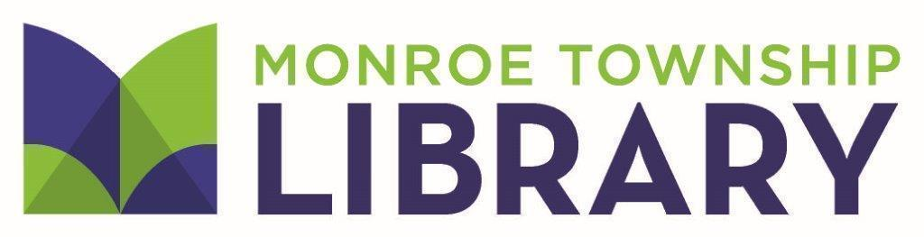
4 Municipal Plaza • Monroe Township, NJ 08831 • (732) 521-5000 • www.monroetwplibrary.org

MINUTES OF THE MONROE TOWNSHIP
LIBRARY BOARD OF TRUSTEES MEETING
May 17, 2022

ATTENDING:
Members Staff Public/Consultants
Benjamin Baum, President Leah Wagner Dr. Marilyn Gonyo
Prena Shah Karen Klapperstuck Allen McGinley
Lisa Chen Patricia Tumulty
Bernadette Yannacci Friends of the Library
Anne Corey Joyce Ragucci
Kelly Roselle (virtual) Francine Kitts
Alton Kinsey
Riya Karnik

The meeting of the Monroe Township Library Board of Trustees was called to order at 6:34 p.m. by Benjamin Baum, President.
STATEMENT OF COMPLIANCE
It was noted that this meeting was in compliance with the Open Public Meetings Act.
STRATEGIC PLAN PRESENTATION
Allen McGinley and Patricia Tumulty from Library Crossroads Consulting presented the Strategic Plan to the Library Board. Allen and Pat discussed the process including the survey and focus groups. The work of the Library’s committee was also recognized.
Allen and Pat reviewed the goals of the new plan and how it will work in development with the Plan of Service that Leah creates each year with Department Heads and Library Staff.
Leah Wagner thanked Allen and Pat, as well as James Keehbler and Cindy Czesak, of Library Crossroads and the Strategic Plan team for the work needed to create the document. The plan helps lay the groundwork for continuing the excellent service that the Library is known for providing to the residents of Monroe Township.

MINUTES OF THE APRIL 19, 2022 MEETING
The minutes from the April 19, 2022 meeting of the Library Board of Trustees were presented.
Prena Shah moved that the minutes of the April 19, 2022 meeting be accepted. Alton Kinsey seconded. All were in favor. The motion passed.
DIRECTOR’S REPORT
Leah Wagner discussed the process for the payments for the Construction Bond Grant. Later in the meeting a resolution will be presented to certify funds from the capital account for payment of bills related to the construction grant. Then the money will be reimbursed by the State when the proper documentation is submitted.
Leah also informed the Board that the Farmers Market has reached capacity for vendors. The market will run every Thursday from June 30 through September 15 between 2pm and 7pm.
Leah announced that the dedication of the Tamburro pergola and seating area will be held on July 18. The time will be finalized soon.
Leah updated the Board on a number of staff changes. Leah and Karen Klapperstuck will work together to assess where changes may be needed in the positions that will now be open.
Leah reminded the Board that it has been quite some time since the last staff in-service. Later in the meeting, she will ask the Board to approve a half-day in-service staff development session with the Library opening at 1pm on September 23, 2022.
The Middlesex County Surrogate Office has asked to use the Library to meet with people in probate to try to get through the backlog caused by COVID related closures and delays.
ASSISTANT DIRECTOR’S REPORT
Karen Klapperstuck was pleased to demonstrate the new RFID self-check process before the meeting started. She thanked all of the Library staff in all departments who have worked on all aspects of the project - from weeding out of date materials, to shifting collections, to tagging items with RFID stickers. This huge project could not have been done without staff involvement at every level.
Karen thanked everyone who served on the Strategic Plan committee for their hard work and thoughtfulness in the development of the new plan presented earlier in the meeting.
FINANCIAL REPORT
Leah Wagner discussed the current financial reports. She also provided copies of the 2019 Audit from the Library’s auditing firm. Leah reminded the Board that the 2020 and 2021 reports should be available soon.
Anne Corey followed up on her question from the April meeting regarding insurance for the Library bank accounts. While consumer accounts are protected by FDIC, municipal bank accounts are also held in Governmental Unit Deposit Protection Act (GUDPA) certified banks. The Library’s bank accounts are protected under GUDPA and FDIC.
COMMITTEE REPORTS
The Display committee will meet after this Board meeting.
The Personnel committee met for the first time earlier in May. The committee discussed the Standard Operating Procedure manual that is being developed by Library staff. The committee also discussed how the committee will function moving forward.
The Policy committee did a review of the Library Board of Trustees by-laws and will look at policy revisions as Library staff update current policies.
TOWNSHIP COUNCIL REPORT
Dr. Kinsey reported on Township happenings. The Mayor and Council heard presentations from Township department heads regarding this year’s budgets. The budget will then go to a public review. Dr Kinsey reminded the Board members of the affordability of the budget and the new budget is flat and stable. Monroe’s municipal tax rating is very good and 99% of the citizens of Monroe pay their taxes.
The Township continues to go for available grants to help meet the needs of the Township and its residents. The Mayor and Council strive to maintain the extraordinary services provided to all residents.
Dr. Kinsey reported that the Knights of Columbus is celebrating its 50th anniversary this year. The Monroe Township High School celebrated Armed Forces Day.
Dr. Kinsey relayed that the Mayor wishes all a safe Memorial Day holiday.
FRIENDS OF THE LIBRARY
Francine Kitts reported on what is new with the Friends of the Library. The Book Sale held at the end of April was a huge success, raising $3,150.25. The mini book sale continues to raise between $100-$200 each month.
Francine thanked Dr. Marilyn Gonyo for her Women in History Book Discussion series. Dr. Gonyo’s research and skill were very much appreciated by all who attended the sessions.
The Friends are partnering with the Library to assist with the Farmers Market.
The Friends are looking at the renewal and usage of the current museum passes
Joyce Ragucci added that the current Friends Board is a dynamic group and Francine has been doing a great job.
MONROE TOWNSHIP SCHOOL ADMINISTRATOR
Kelly Roselle reported that the last School Board meeting was held on May 11. Teacher of the Year awards were announced. Ms. Chanley will continue to serve as interim Superintendent.
Kelly also discussed upcoming cooperative programs and events with the Library regarding summer reading and more.
STUDENT REPRESENTATIVE
Riya Karnik reported that AP testing wrapped up last week and the Junior Prom is scheduled for May 13. The Science Exposition is upcoming and will be on May 26 from 5-8pm.
OLD BUSINESS
Leah Wagner provided an update on the construction project. Dates are not yet determined for the next phase of the project for the air conditioning units to be installed. Leah asked the Board to approve the resolution to move funds for the payment of related bills.
Whereas the Monroe Township Public Library was awarded grant funding under the New Jersey Construction Bond Act (“LCBA”), P.L. 2017, c. 149 in the amount of $248,640, and the library will be responsible to cover the project expenditures until reimbursement from the grant has been made, and,
Whereas the Monroe Township Public Library Board of Trustees wished to expend funds from the Capital Fund,
Now, therefore, does the Monroe Township Public Library Board of Trustees agree to transfer $248,640.00 from the Capital Fund to cover project expenditures until reimbursement has been made.
Lisa Chen made a motion to pass the resolution. Anne Corey seconded the motion. All were in favor.
NEW BUSINESS
Leah Wagner informed the Board about the revisions to the by-laws. There was discussion from the Board members about a number of sections, including the establishment of committees and committee appointments as well as Trustees and Director liability insurance. Given the discussion, the by-laws will be voted on at a later date.
Leah asked the Board to vote on a Staff In-Service to be held on September 23.
Anne Corey made a motion that the Library open to the public at 1pm on September 23 so that the Library may have a staff development program in the morning. Lisa Chen seconded the motion. All were in favor.

ACTION ON BILLS
Prena Shah moved the payment of the April bills with checks #17991 - #18037, in the amount of $270,023.74. Bernadette Yannacci seconded. All were in favor. The motion passed.
OTHER BUSINESS
The next meeting of the Monroe Township Library Board of Trustees is scheduled for Tuesday, June 21 at 6:30 p.m.
ADJOURNMENT
There being no other business, Prena Shah moved that the meeting be adjourned. The meeting adjourned at 8:04 p.m.
Respectfully submitted,
Karen Klapperstuck

